Quester Tangent Corporation
Southeastern Pennsylvania Transportation Authority (SEPTA)
Silverliner V

Central Diagnostic System (CDS)
Communications
Car Monitoring Network
Interface Control Document
Prepared by: | Christian Leclerc  Network Integration Engineer
Verified by: | Jim Kightley  Project Engineer
Approved by: | Jim Kightley  Project Engineer
Issue Date: August 20, 2009
Document Number: DDN-T097-0091
Revision: R03


DATE | Revision | Description
06-Feb-2007 | R00 | Initial release.
08-Jun-2007 | R01 | Node documentation and implementation details added to all sections.
11-July-2007 | R02 | References to nvi02SCIUpdateReq and nvo02SCIUpdateResp removed throughout.  Sec. 4.2.2.1, 4.3.1.1, and 4.3.2.1 updated with information from Meister.
16-Mar-2009 | R03-Draft | Sec. 3.1.1 updated with information about CMK.  Figure 1 updated to add nvi01CDTStBitsA/B and nvi01CDTParamA/B Network Variables.  Sec. 4.2.2.1 and 4.2.4.1 updated to refer to the Diagnostics Data Dictionary.  Added sec 4.2.5–4.2.8 for nvi01CDTStBitsA/B and nvi01CDTParamA/B Network Variables.  Renamed network variables to fit within the 16 characters limit.  Removed all references to SCI update.  Sec. 5.3.1: Extended timeout to allow for extreme cases where data is very sparse on the CDT.  Sec. 6.4: Added nvi01CDTStBitsA/B and nvi01CDTParamA/B to the Network Variable Configuration Table.
23-Mar-2009 | R03-Draft | Sec. 5.3.1: Updated the wayside file transfer diagrams for clarification.  Sec. 4: Updated diagram to show StatusBits2 network variable.  Sec. 4.2.3 and 6.4: Added StatusBits2 network variable.
20-Aug-2009 | R03 | Sec 6.3: Change address table entry #2 retry count from 2 to 3.  Sec 6.4: Revise “nvi” and “nvo” prefixes of network variable names for wayside request and response to reflect message direction from the Communication system perspective.
2010년 10월 | R04 | CDT로 전달하는 버전을 17개에서 42개로 수정
2010년12월 | R05 | 버전 리스트 LIC-MPU추가(버전 항목 42에서 43개 항목)
2012년 5월 | R06 | CI 고장상태 및 중련여부 추가  Sec 4.2.6 : nvi01CDTStBitsA에서 C/I상태 추가  Sec 4.2.2 : nvo01StatusBits 에서 중련 상태 및 C/I상태 추가

COPYRIGHT
Copyright © 2009 by Quester Tangent Corporation. All rights reserved. This item and the information contained herein are the property of Quester Tangent Corporation. No part of this document may be reproduced, transmitted, stored in a retrieval system, or translated into any language or computer language in any form or by any means, electronic, mechanical, magnetic, optical, chemical, manual, or otherwise, without the express written permission of Quester Tangent Corporation.
Quester Tangent Corporation
6582 Bryn Road
Saanichton, BC, Canada V8M 1X6
Tel: 250-656-6677
Fax: 250-655-4696
Table of Contents
1 Introduction 3
2 Network Physical Layer Interface Design 3
3 Network Management 3
3.1 Node Documentation 3
3.1.1 Node Self-Documentation String 3
3.1.2 Node Program ID 3
4 Network Node 3
4.1 Node Object – Object #0 3
4.1.1 nvi00ObjRequest 3
4.1.2 nvo00ObjStatus 3
4.1.3 nvi00CDTCommand 3
4.1.4 nvo00TimeStamp 3
4.1.5 nvi00FileReqA 3
4.1.6 nvo00FileStatA 3
4.1.7 nvi00FileReqB 3
4.1.8 nvo00FileStatB 3
4.1.9 nci00NetConfig 3
4.2 Monitoring Object – Object #1 3
4.2.1 nvi01Subscribe 3
4.2.2 nvo01StatusBits 3
4.2.3 nvo01StatusBits2 3
4.2.4 nvi01TransfState 3
4.2.5 nvo01Parameter 3
4.2.6 nvi01CDTStBitsA 3
4.2.7 nvi01CDTStBitsB 3
4.2.8 nvi01CDTParamA 3
4.2.9 Nvi01CDTParamB 3
4.3 SCI Version Object – Object #3 3
4.3.1 nvi03SCIVersReq 3
4.3.2 nvo03SCIVersion 3
4.4 Wayside Data Transfer Object – Object #4 3
4.4.1 nvi04WaysidRespA 3
4.4.2 nvo04WaysideReqA 3
4.4.3 nvi04WaysidRespB 3
4.4.4 nvo04WaysideReqB 3
5 Network Interface 3
5.1 General 3
5.2 Subsystem Specific Network Interface Declarations 3
5.2.1 UNVT_CDT_command 3
5.2.2 UNVT_wayside_request 3
5.2.3 UNVT_wayside_response 3
5.3 File Transfers 3
5.3.1 Wayside File Transfer Details 3
6 Self-Installation Data 3
6.1 Domain Configuration 3
6.2 Location Configuration 3
6.3 Address Configuration 3
6.4 Network Variable Configuration 3

List of Figures
Figure 1: Communications Node 3
Figure 2: Wayside File Transfer - Single Block 3
Figure 3: Wayside File Transfer - Multiple Blocks 3

List of Tables
Table 1: Communications Subsystem – Network Physical Layer Interface Design 3
Table 2: CDT Commands 3
Table 3: Parameter Data Received from CDT by the Comm System 3
Table 4: SCI Information 3
Table 5: Wayside File Transfer Request Types 3
Table 6: Wayside File Transfer Response Types 3
Table 7: File Transfers 3
Table 8: Address Table 3
Table 9: Network Variable Configuration 3

Introduction
This document defines the Communications subsystem specific interface to the car monitoring network described in the Car Monitoring Network ICD (DDN-T097-0080).
This document is intended as the main tool for development and integration of the Communications subsystem onto the train for the supplier as well as for Hyundai-Rotem and Quester Tangent.
Information contained in this document is essential to the supplier in order to complete the software that will implement the Car Monitoring Network interface. For this reason, any updates of the information contained in this document will be made available to the supplier with the shortest possible delay.
This release of the document captures changes to information between the previous supplier and the current supplier.

Network Physical Layer Interface Design
Table 1 documents the Communications subsystem’s network physical layer interface design. The design does not conform to the Car Monitoring Network ICD Section 4 requirements where noted.
Table 1: Communications Subsystem – Network Physical Layer Interface Design
Feature | Subsystem Info | Notes
Network processor | FT3150
Transceiver type | FT-X1
LEDs (Tx, Rx, Service) | Tx, Rx, Service
Service pushbutton | Yes
Common mode isolation choke | Yes
Magnetic shield | No | Non-conforming
Surge absorbing flash tubes | Yes
Submit subsystem network interface design for review by QT? | Will submit to QT for review on request
Note: WJ should review and update the information in this table.

Network Management
The subsystem shall be capable of self-installation, i.e. set the system’s own network configuration without intervention by a network management tool. Full details of the required settings are provided in the current versions of the Car Monitoring Network ICD document (DDN-T097-0080) and in this document.
All nodes shall support possible future usage of a network management tool, as described in the Car Monitoring Network ICD document.

Node Documentation

Node Self-Documentation String
The Neuron C source code declaration shall be:
#pragma set_node_sd_string "COMM, CMK, PPPP, DDDD"
PPPP: Supplier part number
DDDD: Neuron SCI revision date in format YYYY-MM-DD

Node Program ID
The Neuron C source code declaration shall be:
#pragma set_id_string "COMM"

Network Node
Figure 1 shows the Communications Node functional blocks, network variables and configuration properties. The following subsections provide network variable and configuration property details.
Note: Object numbering is consistent across all subsystems on the train. Object #2 (SCI Update) is not used for the Communications node.
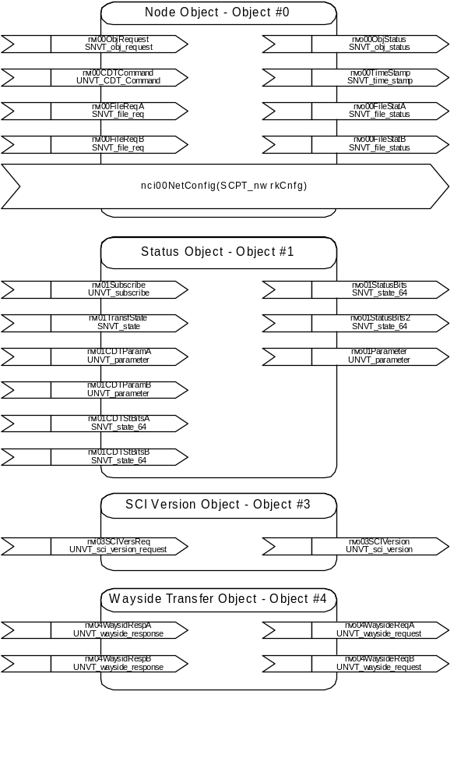
Figure 1: Communications Node

Node Object – Object #0

nvi00ObjRequest
Declaration: network input sd_string("@0|1") SNVT_obj_request nvi00ObjRequest
Description: Mandatory variable defined in LonMark Functional Profile: Node Object, LonMark SNVT Master List. This input variable provides the mechanism to request a particular mode for the node as a whole.

Data Value
Refer to the SNVT Master List and DDN-T097-0080 for request types supported.

nvo00ObjStatus
Declaration: network output sd_string("@0|2") SNVT_obj_status nvo00ObjStatus
Description: Mandatory variable defined in LonMark Functional Profile: Node Object, LonMark SNVT Master List. This output variable reports the general status of the node.
Destination: CDT

Data Value
Refer to the SNVT Master List and DDN-T097-0080 for status items supported.

nvi00CDTCommand
Declaration: network input sd_string("@0|3") UNVT_CDT_command nvi00CDTCommand
Description: Command from the CDT. See section 5.2.1 for the description of this data structure.

Data Value
Table 2: CDT Commands
ID | CDTCommand | Argument | System Info | Notes
1 | Broadcast Time | Unused |  | In response, the Communications subsystem shall update and transmit its nvo00TimeStamp network variable one time. Periodic transmission of the network variable is unaffected.  CDT command will be sent at network startup and as required.

All other nvi00CDTCommand values shall be ignored.

nvo00TimeStamp
Declaration: network output sd_string("@0|4") SNVT_time_stamp nvo00TimeStamp
Description: The Communications subsystem shall provide the current UTC time to all other subsystems (T.S. 9.9) i.e. to all nodes in the car or married pair. The communication system shall send this network variable when receiving a command through the nvi00CDTCommand network variable and once per hour.
Destination: Domain Broadcast

Data Value
Current time in UTC format.

nvi00FileReqA
Declaration: network input sd_string("@0|5") SNVT_file_req nvi00FileReqA
Description: Receives requests from the CDT (Single car or Car A of married pair), used to control file transfer for wayside transfer.

Data Value
See DDN-T097-0080 section 7.2.

nvo00FileStatA
Declaration: network output sd_string("@0|6") SNVT_file_status nvo00FileStatA
Description: Sends file transfer status to the CDT during wayside transfer.
Destination: CDT (Single car or Car A of married pair)

Data Value
See DDN-T097-0080 section 7.2.

nvi00FileReqB
Declaration: network input sd_string("@0|7") SNVT_file_req nvi00FileReqB
Description: Receives requests from the CDT (car B of Married Pair), used to control file transfer for wayside transfer.

Data Value
See DDN-T097-0080 section 7.2.

nvo00FileStatB
Declaration: network output sd_string("@0|8") SNVT_file_status nvo00FileStatB
Description: Sends file transfer status to the CDT during wayside transfer.
Destination: CDT (Car B of married pair)

Data Value
See DDN-T097-0080 section 7.2.

nci00NetConfig
Declaration: config network input sd_string("&0,,0\x90,25;") SCPTnwrkCnfg nci00NetConfig
Description: All nodes must support self-installation and provide a configuration property to allow a network tool to override the node’s self-installation procedure. If the value of this variable is set to CFG_EXTERNAL when the node is reset or powers up, then the node shall not execute any of its self-installation functions. See DDN-T097-0080 section 6.3.5 for details.

Preset Value
This variable shall be initialized to CFG_LOCAL when subsystem software is reloaded and when units are delivered from the factory.

Monitoring Object – Object #1

nvi01Subscribe
Declaration: network input sd_string("@1|1") UNVT_subscribe nvi01Subscribe
Description: Used by the CDT to set the required transmission rate for monitoring data sent to the CDT.

Data Value
See DDN-T097-0080 section 6.5.3.

nvo01StatusBits
Declaration: network output sd_string("@1|2") SNVT_state_64 nvo01StatusBits
Description: Current subsystem status.
Destination: CDT

Data Value
The Silverliner V Diagnostics Data Dictionary defines the status bit assignments and associated attributes for bits 0-55. Bits 56-63 represent a counter.
번호 | 내 용 | Size(byte)
0 | Status bit | 4
1 | 중련상태  - BIT7~3 : spare  - BIT1&0 : 00 => 2Car  - BIT1&0 : 01 => 4Car  - BIT1&0 : 10 => 6Car  - BIT1&0 : 10 => 8Car | 1
2 | 차량 번호  - BIT7~0은 차량번호 8~1에 해당됨 | 1
3 | 각 차량의 C/I 고장 상태비트  - BIT7~0은 차량번호 8~1에 해당됨  - 1 : 고장, 0 : 정상 | 1
4 | 증가 카운터 | 1

nvo01StatusBits2
Declaration: network output sd_string("@1|3") SNVT_state_64 nvo01StatusBits2
Description: Current subsystem status.
Destination: CDT

Data Value
The Silverliner V Diagnostics Data Dictionary defines the status bit assignments and associated attributes for bits 56-111. Bits 112-119 represent a counter.

nvi01TransfState
Declaration: network input sd_string("@1|4") SNVT_state nvi01TransfState
Description: Used by CDT to suspend network traffic during file transfer operations.

Data Value
See DDN-T097-0080 section 6.5.6.

nvo01Parameter
Declaration: network output sd_string("@1|5") UNVT_parameter nvo01Parameter
Description: Current numeric parameter value.
Destination: CDT

Data Value
The Silverliner V Diagnostics Data Dictionary defines the numeric parameter ID assignments and associated attributes (if any).

nvi01CDTStBitsA
Declaration: network input sd_string(“@1|6”) SNVT_state_64 nvi01CDTStBitsA
Description: Current status information reported by other subsystems, CDT digital inputs or the CDT. The network variable is sent by the CDT in single car or car A of a married pair every two (2) seconds.

Data Value
The Silverliner V Diagnostics Data Dictionary defines the CDT status assignments available to other car subsystems (if required).
번호 | 내 용 | Size(byte)
0 | BIT7 : spare  BIT6 : spare  BIT5 : spare  BIT4 : spare  BIT3 : spare  BIT2 : all door close  BIT1 : traction command  BIT0 : active cap key | 1
1 | spare | 3
2 | 차량의 C/I 고장 상태비트  - BIT7~0은 차량번호 8~1차에 해당됨  - 1 : 고장, 0 : 정상 | 1
3 | spare | 3

nvi01CDTStBitsB
Declaration: network input sd_string(“@1|7”) SNVT_state_64 nvi01CDTStBitsB
Description: Current status information reported by other subsystems, CDT digital inputs or the CDT. The network variable is sent by the CDT in car B of a married pair every two (2) seconds.

Data Value
The Silverliner V Diagnostics Data Dictionary defines the CDT status assignments available to other car subsystems (if required).

nvi01CDTParamA
Declaration: network input sd_string(“@1|8”) UNVT_parameter nvi01CDTParamA
Description: Current numeric parameter value sent by the CDT in single car or car A of a married pair.

Data Value
The following table defines the numeric parameter ID assignments.
Table 3: Parameter Data Received from CDT by the Comm System
ID | Description | Units or scale/offset | Transmission Rate | Notes
5 | Car Number | Analog | 60 sec
?? | All Door Closed | Analog | 60 sec
The Silverliner V Diagnostics Data Dictionary defines all the CDT parameters assignments available to other car subsystems.

Nvi01CDTParamB
Declaration: network input sd_string(“@1|9”) UNVT_parameter nvi01CDTParamB
Description: Current numeric parameter value sent by the CDT in car B of a married pair.

Data Value
Refer to section 4.2.8.1, CDT from both Car A and Car B send the same type of information.

SCI Version Object – Object #3

nvi03SCIVersReq
Declaration: network input sd_string("@3|1") UNVT_sci_version_request nvi03SCIVersReq
Description: Used by CDT to request SCI version information. SCI identified by index number.

Data Value
Refer to the table in section 4.3.2.1 for the complete list of subsystem SCIs.
LWI Neuron SCI (index 32) update can be performed by Network Diagnostic Equipment via the car monitoring network. None of the other subsystem SCIs can be updated via the CDT; refer to Communications subsystem documentation for the software update mechanism.

nvo03SCIVersion
Declaration: network output sd_string("@3|2") UNVT_sci_version nvo03SCIVersion
Description: Populated by subsystem with requested SCI version information.
Destination: CDT

Data Value
The following table documents SCI information. DDN-T097-0080 section 6.7.2 describes SCI types.
Table 4: SCI Information
SCI Index | SCI Name (Note 1) | SCI Type (Note 1) | SCI Name (8 Char) (Note 1)
1 | TRIC, A/F | 2 | TRIC1
2 | TRIC, B | 2 | TRIC2
3 | CCP, F/A end | 2 | CCP1
4 | CCP, B | 2 | CCP2
5 | LIC-LON | 3 | LIC-LON
6 | LIC-MPU | 2 | LIC-MPU
7 | GIA | 2 | GIA
8 | VTX | 2 | VTX
9 | PAC, F/A | 2 | PAC1
10 | PAC, B | 2 | PAC2
11 | FDI, F /A | 2 | FDI 1
12 | FDI, B | 2 | FDI 2
13 | SDI 1 | 2 | SDI1
14 | SDI 2 | 2 | SDI2
15 | SDI 3 | 2 | SDI3
16 | SDI 4 | 2 | SDI4
17 | SDI 5 | 2 | SDI5
18 | SDI 6 | 2 | SDI6
19 | SDI 7 | 2 | SDI7
20 | SDI 8 | 2 | SDI8
21 | PII 1 | 2 | PII1
22 | PII 2 | 2 | PII2
23 | PII 3 | 2 | PII3
24 | PII 4 | 2 | PII4
25 | VRX 1 | 2 | VRX1
26 | VRX 2 | 2 | VRX2
27 | VRX 3 | 2 | VRX3
28 | VRX 4 | 2 | VRX4
29 | VRX 5 | 2 | VRX5
30 | VRX 6 | 2 | VRX6
31 | VRX 7 | 2 | VRX7
32 | VRX 8 | 2 | VRX8
33 | VRX 9 | 2 | VRX9
34 | VRX 10 | 2 | VRX10
35 | VRX 11 | 2 | VRX11
36 | VRX 12 | 2 | VRX12
37 | CN-MAIN | 2 | CN-MAIN
38 | CN-LAUN | 2 | CN-LAUN
39 | CN-UP | 2 | CN-UP
40 | CN-PPLAY | 2 | CN-PPLAY
41 | CN-SPLAY | 2 | CN-SPLAY
42 | CN-FTPDATA | 2 | CN-FTPDATA
43 | CN-CDTDATA | 2 | CN-CDTDATA

Note 1: To be provided by subsystem supplier. See DDN-T097-0080 (Section 6.7.2 nvoSCIVersion) for details.

Wayside Data Transfer Object – Object #4

nvi04WaysidRespA
Declaration: network input sd_string("@4|1") UNVT_wayside_response nvi04WaysidRespA
Description: Response from a CDT (Single car or Car A of married pair) in support of Wayside data transfer. See section 5.2.3 for the description of the data structure.

Data Value
See section 5.2.3.

nvo04WaysideReqA
Declaration: network output sd_string("@4|2") UNVT_wayside_request nvo04WaysideReqA
Description: Signals the CDT to manage the Wayside file transfer. See section 5.2.2 for the description of the data structure.
Destination: CDT (Single car or Car A of married pair)

Data Value
See section 5.2.2.

nvi04WaysidRespB
Declaration: network input sd_string("@4|3") UNVT_wayside_response nvi04WaysidRespB
Description: Response from a CDT (Car B of married pair) in support of Wayside data transfer. See section 5.2.3 for the description of the data structure.

Data Value
See section 5.2.3.

nvo04WaysideReqB
Declaration: network output sd_string("@4|4") UNVT_wayside_request nvo04WaysideReqB
Description: Signals the CDT to manage the Wayside file transfer. See section 5.2.2 for the description of the data structure.
Destination: CDT (Car B of married pair)

Data Value
See section 5.2.2.

Network Interface

General
The Communications subsystem complies with the general monitoring scheme defined in DDN-T097-0080 section 6.

Subsystem Specific Network Interface Declarations
Declarations in this section use Neuron C conventions, i.e. ‘short’ is an 8-bit value, ‘long’ is 16-bits and ‘quad’ is 32-bits.

UNVT_CDT_command
UNVT_CDT_command structure declaration:
typedef struct {
unsigned short command_id;
unsigned long command_arg;
} UNVT_CDT_command;
Field descriptions:
- command_id: Identifies the command that is being sent; its valid range is 1 to 255. A value of 0 shall not be used.
- command_arg: Optional argument to the command. It shall be set to 0 if the argument is unused.

UNVT_wayside_request
UNVT_wayside_request structure declaration:
typedef struct {
unsigned short request;
unsigned quad time_stamp;
} UNVT_wayside_request;
Field descriptions:
- request: Identifies the Wayside processing transfer request. Table 5 shows the valid request values. The receiver shall ignore any invalid value.
- time_stamp: Time reference for the last received log entry. Time is stored as seconds since midnight Jan 1, 2000.
Table 5: Wayside File Transfer Request Types
request number | Request Name | TimeStamp | Description
1 | Start Recent Faults | Ignored | Used to initiate transfer of filtered CDT log entries. CDT maintains timestamp from last successful transfer and will ignore any time_stamp data.
2 | Ack Recent Faults | Required | Used to acknowledge the Recent Faults transfer. The timestamp confirms the last successfully received entry.
3 | Start Historical | Required | Used to initiate transfer of complete CDT log. Comms populates the time_stamp data from Wayside request. If time_stamp set to 0, CDT will begin file transfer from last successful confirmed Historical transfer. The Start Historical is also used to confirm the last block of Historical transfer and to initiate the next block.
4 | Ack Historical | Required | Used to acknowledge the last block of Historical transfer. Time_stamp is set to the last successfully received entry.

UNVT_wayside_response
UNVT_wayside_response structure declaration:
typedef struct {
unsigned short response;
} UNVT_wayside_response;
Field descriptions:
- response: Identifies the CDT response to Wayside processing transfer requests. Table 6 shows the valid response values. The receiver shall ignore any invalid value.
Table 6: Wayside File Transfer Response Types
Response number | Response Name | Description
1 | Yes | New entries recorded in CDT log since last transfer (Recent Faults type) or since time stamp requested (Historical type). The CDT will initiate a file transfer of the type requested.
2 | No | No new entries available. The CDT will not initiate a file transfer.

File Transfers
Table 7: File Transfers
Index | File Type | Sender | Receiver | Initiator | Notes
301 | Wayside File | CDT | Comms | CDT | Used for both Recent Faults and Historical

Wayside File Transfer Details
Two different wayside file transfers are defined for the CDT: Recent Faults and Historical. The Communications subsystem shall determine which transfer type is appropriate based on location. The Communications subsystem shall be responsible for ensuring successful delivery of the transferred data.
The Communications subsystem shall be responsible for signalling each CDT for file transfers in a married pair configuration. These transfers shall occur sequentially so as to avoid network congestion.
The wayside file transfer protocol is as described in Echelon LonWorks Engineering Bulletin: File Transfer. The following modifications are required:
- File Packet Size = 128 data bytes (standard protocol uses 32 bytes)
- Receiver Timeout = 5000 msec
- Sender Timeout = 5000 msec
The following figures illustrate the sequence of messages between the Communications subsystem and the CDT for wayside file transfers. Figure 2 shows the messages for transferring a single block of CDT log. This will be typical for the transfer of Recent Faults. Figure 3 shows the messages for transferring multiple blocks of CDT log. This will be typical for the transfer of Historical logs.
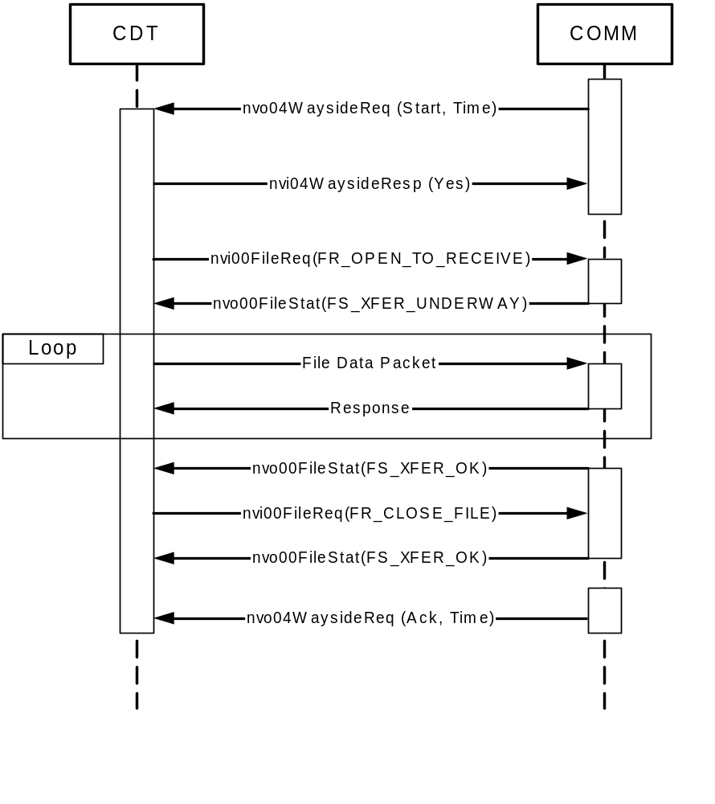
Figure 2: Wayside File Transfer - Single Block
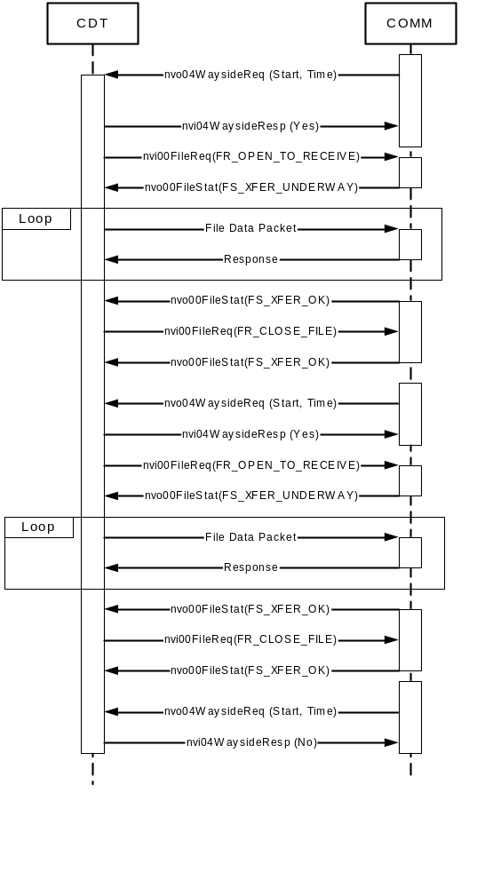
Figure 3: Wayside File Transfer - Multiple Blocks

Self-Installation Data
The following tables define the data needed to configure the node’s network image to support self-installation.

Domain Configuration
Refer to DDN-T097-0080 section 5.1 for domain configuration details.

Location Configuration
The Neuron C source code configuration data declaration shall include:
config_data.location[0] = 'C';
config_data.location[1] = 'O';
config_data.location[2] = 'M';
config_data.location[3] = 'M';
config_data.location[4] = ' ';
config_data.location[5] = ' ';

Address Configuration
Table 8: Address Table
ENTRY | Type | Domain | Node | Repeat Timer | Retry | Receive Timer | Transmit Timer | Subnet
0 | 1 | 0 | 1 | 0 | 3 | 0 | 4 | 1
1 | 1 | 0 | 1 | 0 | 3 | 0 | 4 | 2
2 | 3 | 0 | 0 | 3 | 3 | 0 | 0 | 0
3 | 0 | 0 | 0 | 0 | 0 | 0 | 0 | 0
4 | 0 | 0 | 0 | 0 | 0 | 0 | 0 | 0
5 | 0 | 0 | 0 | 0 | 0 | 0 | 0 | 0
6 | 0 | 0 | 0 | 0 | 0 | 0 | 0 | 0
7 | 0 | 0 | 0 | 0 | 0 | 0 | 0 | 0
8 | 0 | 0 | 0 | 0 | 0 | 0 | 0 | 0
9 | 0 | 0 | 0 | 0 | 0 | 0 | 0 | 0
10 | 0 | 0 | 0 | 0 | 0 | 0 | 0 | 0
11 | 0 | 0 | 0 | 0 | 0 | 0 | 0 | 0
12 | 0 | 0 | 0 | 0 | 0 | 0 | 0 | 0
13 | 0 | 0 | 0 | 0 | 0 | 0 | 0 | 0
14 | 0 | 0 | 0 | 0 | 0 | 0 | 0 | 0

Network Variable Configuration
Table 9: Network Variable Configuration
Entry | Variable | Direction | Prio | Service | Selector | Address Index
0 | nci00NetConfig | 0 (IN) | 0 | ACKD | 0x0816 | 0x0F
1 | nvi00ObjRequest | 0 (IN) | 0 | ACKD | 0x0801 | 0x0F
2 | nvo00ObjStatus | 1 (OUT) | 0 | ACKD | 0x0802 | 0x00
3 | nvo00TimeStamp | 1 (OUT) | 0 | UNACKD_RPT | 0x0803 | 0x02
4 | nvi00FileReqA | 0 (IN) | 0 | ACKD | 0x0804 | 0x0F
5 | nvo00FileStatA | 1 (OUT) | 0 | ACKD | 0x0805 | 0x00
6 | nvi00FileReqB | 0 (IN) | 0 | ACKD | 0x0884 | 0x0F
7 | nvo00FileStatB | 1 (OUT) | 0 | ACKD | 0x0885 | 0x01
8 | nvi00CDTCommand | 0 (IN) | 0 | ACKD | 0x0811 | 0x0F
9 | nvi01Subscribe | 0 (IN) | 0 | ACKD | 0x0806 | 0x0F
10 | nvi01TransfState | 0 (IN) | 0 | UNACKD | 0x0109 | 0x0F
11 | nvo01StatusBits | 1 (OUT) | 0 | ACKD | 0x080A | 0x00
12 | nvo01StatusBits2 | 1(OUT) | 0 | ACKD | 0x080B | 0x00
13 | nvo01Parameter | 1 (OUT) | 0 | UNACKD | 0x080C | 0x00
14 | nvi01CDTStBitsA | 0 (IN) | 0 | UNACKD | 0x0108 | 0x0F
15 | nvi01CDTStBitsB | 0 (IN) | 0 | UNACKD | 0x0188 | 0x0F
16 | nvi01CDTParamA | 0 (IN) | 0 | UNACKD | 0x0107 | 0x0F
17 | nvi01CDTParamB | 0 (IN) | 0 | UNACKD | 0x0187 | 0x0F
18 | nvi03SCIVersReq | 0 (IN) | 0 | ACKD | 0x080F | 0x0F
19 | nvo03SCIVersion | 1 (OUT) | 0 | ACKD | 0x0810 | 0x00
20 | nvo04WaysideReqA | 1 (OUT) | 0 | ACKD | 0x0114 | 0x00
21 | nvi04WaysidRespA | 0 (IN) | 0 | ACKD | 0x0115 | 0x0F
22 | nvo04WaysideReqB | 1 (OUT) | 0 | ACKD | 0x0194 | 0x01
23 | nvi04WaysidRespB | 0 (IN) | 0 | ACKD | 0x0195 | 0x0F

Note 1: Turnaround and Authentication are set to zero (0) for all variables listed.

